**Topics: Descriptive Statistics and Probability**

1. Look at the data given below. Plot the data, find the outliers and find out $μ, σ, σ^{2}$

|  |  |
| --- | --- |
| **Name of company** | **Measure X** |
| Allied Signal | 24.23% |
| Bankers Trust | 25.53% |
| General Mills | 25.41% |
| ITT Industries | 24.14% |
| J.P.Morgan & Co. | 29.62% |
| Lehman Brothers | 28.25% |
| Marriott | 25.81% |
| MCI | 24.39% |
| Merrill Lynch | 40.26% |
| Microsoft | 32.95% |
| Morgan Stanley | 91.36% |
| Sun Microsystems | 25.99% |
| Travelers | 39.42% |
| US Airways | 26.71% |
| Warner-Lambert | 35.00% |

1.1-Plot the data

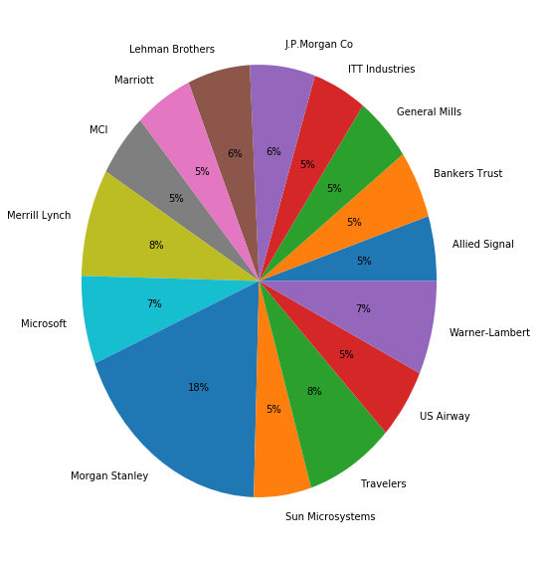

1.2 To find Outliers I Used Box Plot-

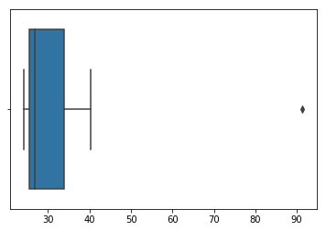

There is one Outlier which have the value above 90i.e. **91.36**

1.3 Mean (µ) = 33.2713333

1.4 STD ($σ$) = 16.9454

1.5 Var ($σ^{2}$) = 287.1476



Answer the following three questions based on the box-plot above.

1. What is inter-quartile range of this dataset? (please approximate the numbers) In one line, explain what this value implies.

**Ans.** Approx., 1St quartile range Q1=5, 3rd quartile range somewhere around Q3= 12.

Hence, IQR= Q3 – Q1

= 12 – 5 =**7**

Also, this range is equal to median quartile.

1. What can we say about the skewness of this dataset?

**Ans.** Dataset is Right skewed

1. If it was found that the data point with the value 25 is actually 2.5, how would the new box-plot is affected?

**Ans.** Then, it will be no outliers and hence, it will affect on skewness of data. Like the data will show Normally Distributed.



Answer the following three questions based on the histogram above.

1. Where would the mode of this dataset lie?

**Ans.** The Mode is lies between approximately from 4 to 8.

1. Comment on the skewness of the dataset.

**Ans**. The dataset is Right Skewed.

1. Suppose that the above histogram and the box-plot in question 2 are plotted for the same dataset. Explain how these graphs complement each other in providing information about any dataset.

**Ans**. First thing both are Right Skewed data. Secondly, both have the outliers. We can easily identify the median in Box plot whereas Mode is easily visualize is histogram.

1. AT&T was running commercials in 1990 aimed at luring back customers who had switched to one of the other long-distance phone service providers. One such commercial shows a businessman trying to reach Phoenix and mistakenly getting Fiji, where a half-naked native on a beach responds incomprehensibly in Polynesian. When asked about this advertisement, AT&T admitted that the portrayed incident did not actually take place but added that this was an enactment of something that “could happen.” Suppose that one in 200 long-distance telephone calls is misdirected. What is the probability that at least one in five attempted telephone calls reaches the wrong number? (Assume independence of attempts.)

**Ans.** IF 1 in 200 long-distance telephone calls are getting misdirected.  
probability of call misdirecting = 1/200 Probability of call not Misdirecting = 1-1/200 = 199/200 The probability for at least one in five attempted telephone calls reaches the wrong number Number of Calls = 5 n = 5 p = 1/200 q = 199/200 P(x) = at least one in five attempted telephone calls reaches the wrong number P(x) = ⁿCₓ pˣ qⁿ⁻ˣ P(x) = (nCx) (p^x) (q^n-x) # nCr = n! / R! * (n - R)! P (1) = (5C1) (1/200)^1 (199/200)^5-1 P(1) = **0.0245037.**

1. Returns on a certain business venture, to the nearest $1,000, are known to follow the following probability distribution

|  |  |
| --- | --- |
| x | P(x) |
| -2,000 | 0.1 |
| -1,000 | 0.1 |
| 0 | 0.2 |
| 1000 | 0.2 |
| 2000 | 0.3 |
| 3000 | 0.1 |

1. What is the most likely monetary outcome of the business venture?

Ans. As we can see, most likely monetary outcome is $2000 because,it have highest Probability 0.3 than other.

1. Is the venture likely to be successful? Explain

**Ans**. Yes, because the probability of venture will make more than 0 or profit is p(x>0) +p(x>1000) +p(x>2000) +p(x>3000) =0.2+0.2+0.3+0.1=0.8

That means 80% Chances that venture will successful.

1. What is the long-term average earning of business ventures of this kind? Explain

**Ans.** The long term average is Expected value=∑ X*p(x)

=800 $

Hence, average return will be **$800.**

1. What is the good measure of the risk involved in a venture of this kind? Compute this measure

**Ans.** The good measure of the risk involved in a venture of this kind depends on the Variability in the distribution. Higher Variance means more chances of risk Var (X) = E(X^2) – (E(X))^2 = 2800000 – 800^2 = 2160000